Q1: - Create a UML diagram of Admission system using Rational Rose.

Result:-

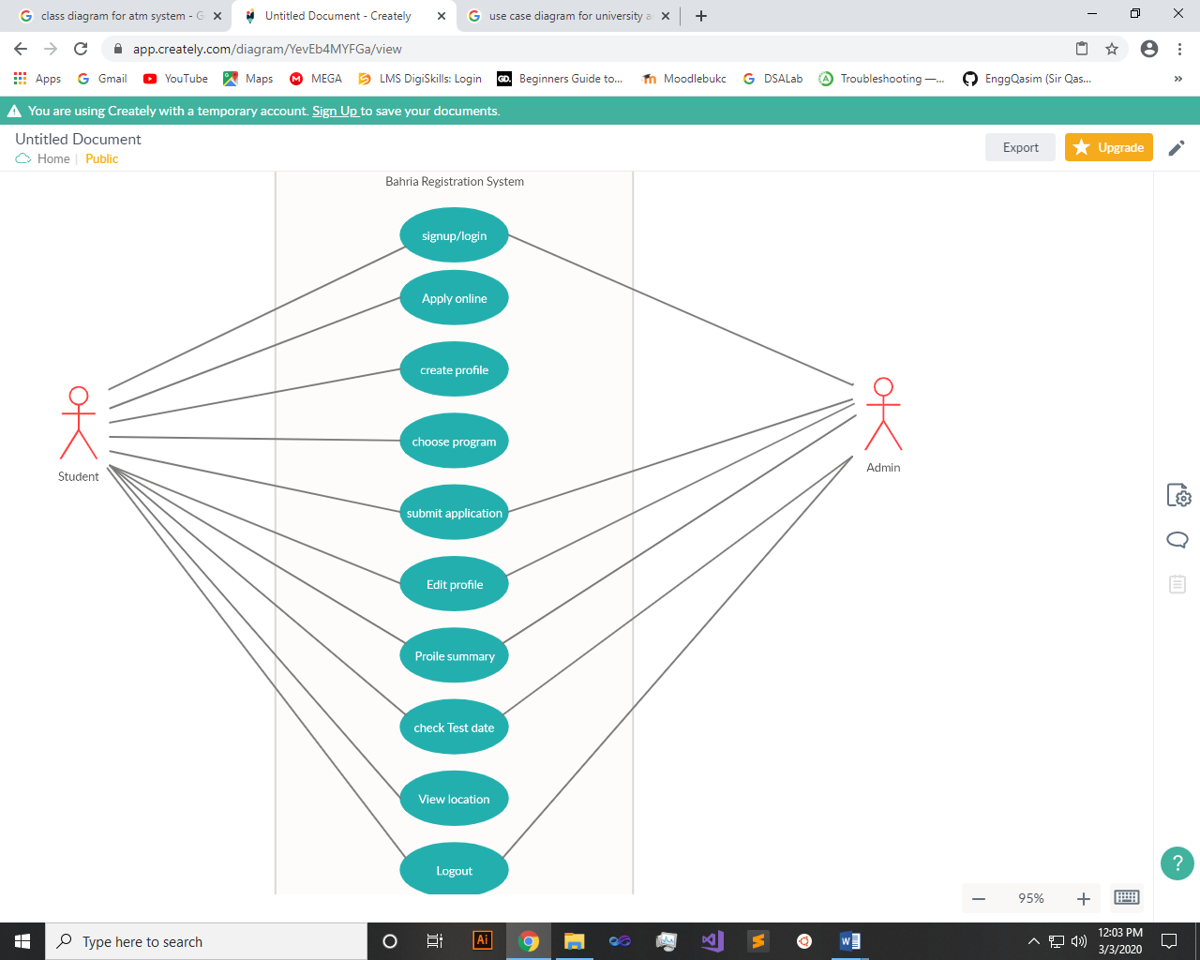

Q2: - Create a UML diagram of ATM system using Rational Rose.

Result:-

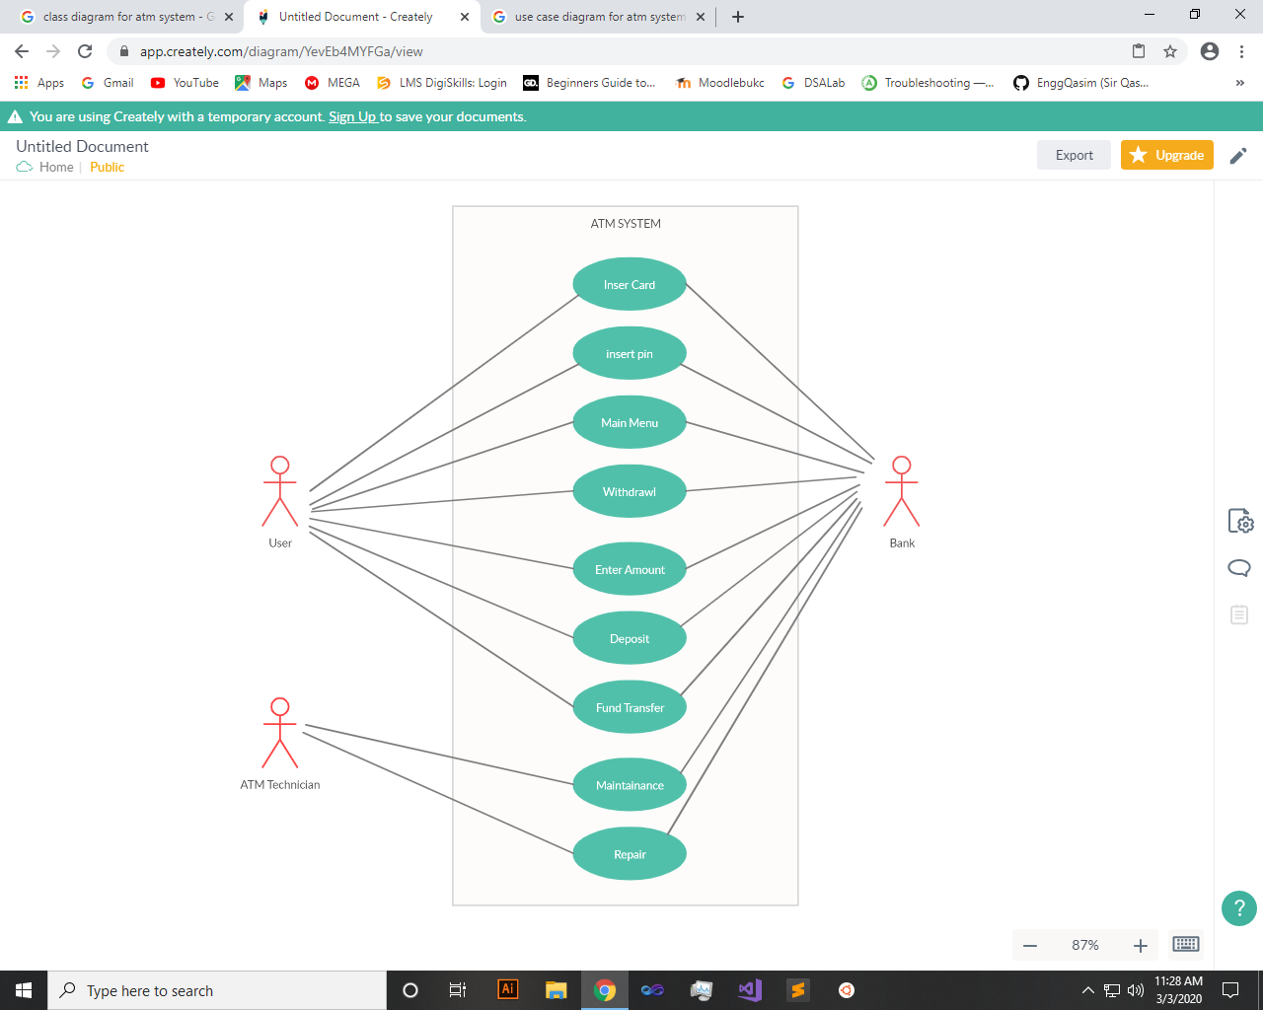

~~~~~~**/**THE END**/**~~~~~~